Lab no 1
OBJECT: Creating applications using Datagram sockets.
Creating applications using Datagram sockets.
Modify the sample code so that the sender uses the same socket to send the same message to two different receivers. Start the two receivers first, then the sender. Does each receiver receive the message? Capture the code and output. Describe the outcome
Code:
import java.net.*;
import java.io.*;
public class Lab1Task1{
public static void main(String[] args){
// this application sends message using connectionless datagram socket
if(args.length!=6)
System.out.println("this program requires six command line arguments");
else{
try{
InetAddress receiverHost=InetAddress.getByName(args [0]);
int receiverPort= Integer.parseInt(args [1]);
String message=args[2];
DatagramSocket mySocket=new DatagramSocket();
byte[] buffer=message.getBytes();
DatagramPacket datagram=new DatagramPacket(buffer,buffer.length,receiverHost,receiverPort);
mySocket.send(datagram);
mySocket.close();
}
catch(Exception e){
e.printStackTrace();
}
try{
InetAddress receiverHost1=InetAddress.getByName(args[3]);
int receiverPort1= Integer.parseInt(args [4]);
String mess1=args[5];
DatagramSocket mySocket1=new DatagramSocket();
byte[] buffer1=mess1.getBytes();
DatagramPacket datagram1=new DatagramPacket(buffer1,buffer1.length,receiverHost1,receiverPort1);
mySocket1.send(datagram1);
mySocket1.close();
}
catch(Exception e){
e.printStackTrace();
}
} } }
Receiver:
import java.net.*;
import java.io.*;

public class ExampleReceiver{
public static void main(String[] args)
{
if (args.length!=1)
System.out.println("This program requires a command line argument.");
else
{
int port =Integer.parseInt(args[0]);
final int MAX_LEN=10;
try
{
DatagramSocket mySocket= new DatagramSocket(port);
byte[] buffer= new byte[MAX_LEN];
DatagramPacket datagram= new DatagramPacket(buffer, MAX_LEN);
mySocket.receive(datagram);
String message= new String(buffer);
System.out.println(message);
Thread.sleep(30000);
System.out.print("Exiting");
mySocket.close(); }
catch(Exception ex)
{ ex.printStackTrace();} } } }

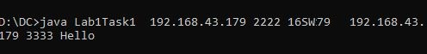
Task 2:Modify the sample code so that the receiver loops five times to repeatedly receive then display your bio data (name, roll num etc.) received. Recompile. Then
i. start the receiver
ii. Execute the sender, sending your bio data, and
iii. In another window, start another instance of the sender, sending your friend’s bio data. Does the receiver receive both the messages? Capture the code and output.

Client.java:
import java.net.*;
import java.io.*;
public class Lab1Task2{
public static void main(String[] args){
// this application sends message using connectionless datagram socket
if(args.length!=3)
System.out.println("requires 3 command line arguments");
else{
try{
InetAddress receiverHost=InetAddress.getByName(args [0]);
int receiverPort= Integer.parseInt(args [1]);
String message=args[2];
DatagramSocket mySocket=new DatagramSocket();
byte[] buffer=message.getBytes();
DatagramPacket datagram=new DatagramPacket(buffer,buffer.length,receiverHost,receiverPort);
mySocket.send(datagram);
mySocket.close();
}
catch(Exception e){
e.printStackTrace();
}}}}

Server.java:
import java.net.*;
import java.io.*;

public class ServerTask2{
public static void main(String[] args)
{
int a=0;
if (args.length!=1)
System.out.println("This program requires a command line argument.");
else
{
int port =Integer.parseInt(args[0]);
while(a<5){
final int MAX_LEN=10;
try
{
DatagramSocket mySocket= new DatagramSocket(port);
byte[] buffer= new byte[MAX_LEN];
DatagramPacket datagram= new DatagramPacket(buffer, MAX_LEN);
mySocket.receive(datagram);
String message= new String(buffer);
System.out.println(message);
Thread.sleep(10000);
System.out.print("Exiting");
mySocket.close(); }
catch(Exception ex)
{ ex.printStackTrace();
a++;}
} } } }
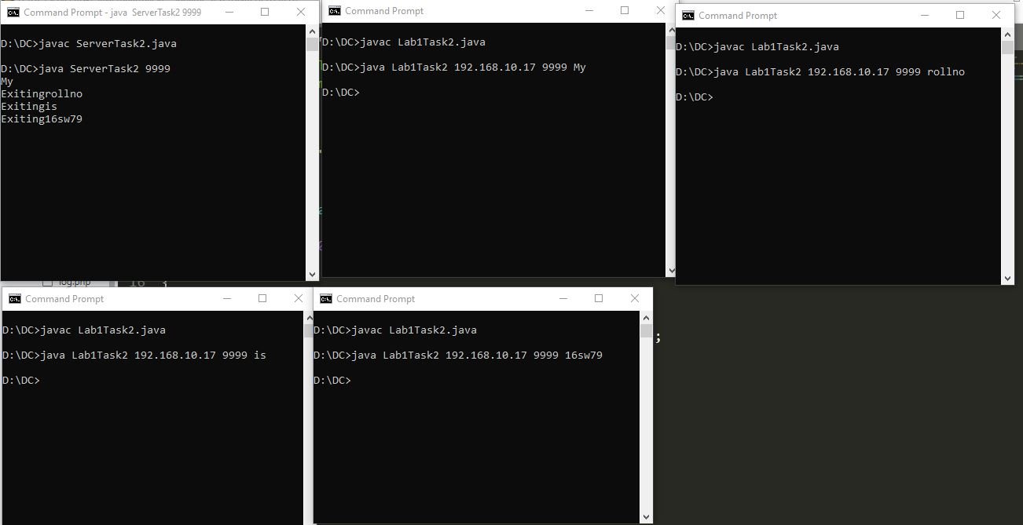
Task 3:Implement an encoding client-server application. The client sends a sentence to the server using datagram packet, the server accepts it and then encodes the sentence using any simple encoding algorithm (for e.g. letters reversal etc.) and sends the encoded sentence back to the client using a datagram packet.

Sender:
import java.io.*;
import java.net.*;
public class ChatClient{
public static void main(String[] args) throws Exception{
Socket sock = new Socket("127.0.0.1", 3000);
// reading from keyboard (keyRead object)
BufferedReader read = new BufferedReader(new InputStreamReader(System.in));
// sending to client (pwrite object)
OutputStream ostream = sock.getOutputStream();
PrintWriter pwrite = new PrintWriter(ostream, true);

// receiving from server ( receiveRead object)
InputStream istream = sock.getInputStream();
BufferedReader receiveRead = new BufferedReader(new InputStreamReader(istream));

System.out.println("Start the chitchat, type and press Enter key");

String receiveMessage, sendMessage;
System.out.println("client");
while(true)
{

sendMessage = read.readLine(); // keyboard reading

pwrite.println(sendMessage); // sending to server
pwrite.flush(); // flush the data
if((receiveMessage = receiveRead.readLine()) != null) //receive from server
{
System.out.println(receiveMessage); // displaying at DOS prompt
}
}
}
}

Receiver:
import java.io.*;
import java.net.*;
public class ChatServer{
public static void main(String[] args) throws Exception{
ServerSocket sersock = new ServerSocket(3000);
System.out.println("Server ready for chatting");
Socket sock = sersock.accept( );
// reading from keyboard (keyRead object)
BufferedReader kRead = new BufferedReader(new InputStreamReader(System.in));
// sending to client (pwrite object)
OutputStream ostream = sock.getOutputStream();
PrintWriter p = new PrintWriter(ostream, true);

// receiving from server ( receiveRead object)
InputStream istream = sock.getInputStream();
BufferedReader reader = new BufferedReader(new InputStreamReader(istream));

String receiveMessage, sendMessage;
System.out.println("server :");
while(true)
{
if((receiveMessage = reader.readLine()) != null)
{
System.out.println(receiveMessage);
}
sendMessage = kRead.readLine();
p.println(sendMessage);
p.flush();
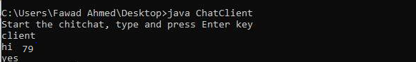
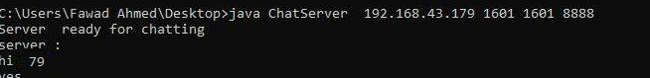
TASK:4 (Broadcast and Multicast)
Implement two simple programs using Java datagram sockets, which broadcasts and multicast your roll number to all or selected network nodes respectively.
1)Broadcast program
Receiver:
import java.net.*;
import java.io.*;

public class Task4Receiver{
public static void main(String[] args)
{
if (args.length!=1)
System.out.println("This program requires a command line argument.");
else
{
int port =Integer.parseInt(args[0]);
final int MAX_LEN=10;
try
{
DatagramSocket mySocket= new DatagramSocket(port);
byte[] buffer= new byte[MAX_LEN];
DatagramPacket datagram= new DatagramPacket(buffer, MAX_LEN);
mySocket.receive(datagram);
String message= new String(buffer);
System.out.println(message);
Thread.sleep(30000);
System.out.print("Exiting");
mySocket.close(); }
catch(Exception ex)
{ ex.printStackTrace();} } } }

Sender:
import java.net.*;
import java.io.*;
import java.util.*;
public class BroadcastingClientTask1 {
static DatagramSocket socket = null;

public static void main(String[] args)throws IOException {
broadcast("16sw79", InetAddress.getByName("255.255.255.255"));
}

public static void broadcast(
String broadcastMessage, InetAddress address) throws IOException {
socket = new DatagramSocket();
socket.setBroadcast(true);

byte[] buffer = broadcastMessage.getBytes();

DatagramPacket packet
= new DatagramPacket(buffer, buffer.length, address, 1601);
socket.send(packet);
socket.close();
}

List<InetAddress> listAllBroadcastAddresses() throws SocketException {
List<InetAddress> broadcastList = new ArrayList<>();
Enumeration<NetworkInterface> interfaces = NetworkInterface.getNetworkInterfaces();
while (interfaces.hasMoreElements()) {
NetworkInterface networkInterface = interfaces.nextElement();

if (networkInterface.isLoopback() || !networkInterface.isUp()) {
continue;
}

networkInterface.getInterfaceAddresses().stream()
.map(a -> a.getBroadcast())
.filter(Objects::nonNull)
.forEach(broadcastList::add);
}
return broadcastList;
}}

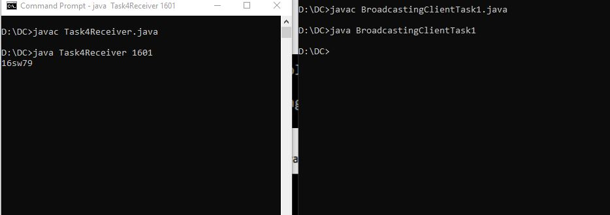

Task5:Multicasting:
Publisher:
import java.net.*;
import java.io.*;
public class MulticastPublisher {
public static void main(String args[]) throws IOException{
multicast("16sw79");}
private static DatagramSocket socket;
private static InetAddress group;
private static byte[] buf;

public static void multicast(String multicastMessage) throws IOException {
socket = new DatagramSocket();
group = InetAddress.getByName("230.0.0.0");
buf = multicastMessage.getBytes();

DatagramPacket packet = new DatagramPacket(buf, buf.length, group, 4446);
socket.send(packet);
socket.close();
}
}
Receiver:
import java.net.*;
import java.io.*;
public class MulticastReceiver {
protected static MulticastSocket socket = null;
protected static byte[] buf = new byte[256];

public static void main(String args[]) throws IOException {
socket = new MulticastSocket(4446);
InetAddress group = InetAddress.getByName("230.0.0.0");
socket.joinGroup(group);
while (true) {
DatagramPacket packet = new DatagramPacket(buf, buf.length);
socket.receive(packet);
String message=new String(buf);
System.out.println(message);
String received = new String(packet.getData(), 0, packet.getLength());
if ("end".equals(received)) {
break;
}
}
socket.leaveGroup(group);
socket.close();
}
}
